Concept
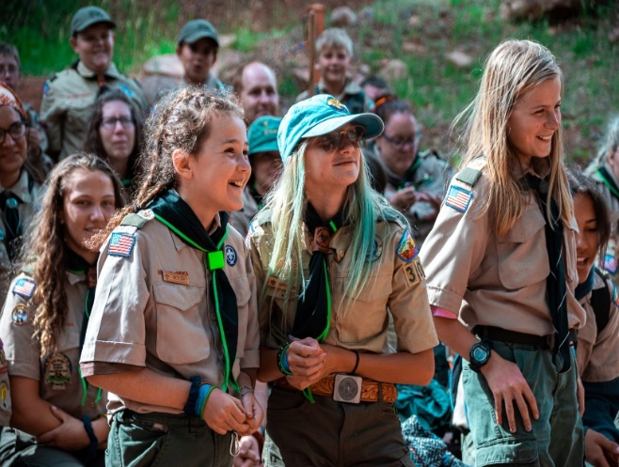
Each fall, Scouts BSA Troops get a “fresh start” as they kick-off the next school year and celebrate the fun adventures they shared through Summer Camp and High Adventure. It often also brings the chance for new families to join the troop as Scouts make new friends and share their summer adventures with friends from the year before.

Somewhere amidst all the hustle and bustle of Back to School and Summer Camp recovery, many returning families do not get contacted to come back and an essential opportunity is missed. As a result, youth are lost along with potential leadership from their families. The “Back to Pack” or “Regroup the Troop” concept is an effort to get all returning Scouts and their parents reengaged before recharter and the new year begins.

To ensure that every Scout knows that the new year of Scouting is about to start and that every family is expected to play and active roll, it is recommended that each Troop hold a “Regroup the Troop” event. With this event, the Troop has an opportunity to set a new tone for full family engagement.

Overview

Across the nation, the best Packs conduct “Back to the Pack” events in the month of June and July. We have expanded and rebranded that same idea for our Scouts BSA Troops, Crews, and Ships. It is important to remember, this is an internal event for existing members. The purpose of the meeting will be to get returning families signed up for the upcoming Scouting year, recruit leadership to fill vacancies and to share plans for the upcoming year.

We encourage you to make this a fun event for the entire Troop and even the family. The event is designed to increase retention and make sure that your Troop is ready for recharter and organized prior to the kick-off of the school year and welcoming in new families.

Promotion
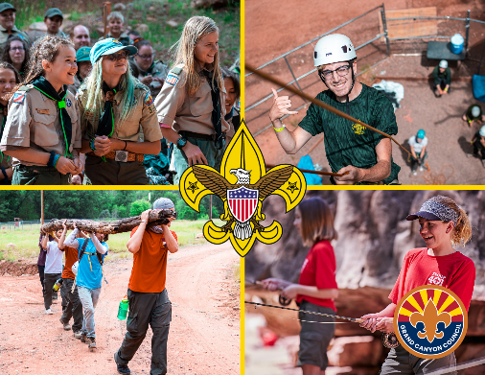
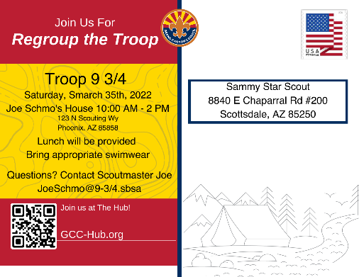
Each Troop should personally contact each family, preferably by phone, to invite them to the event. Research has shown that many families don’t continue simply because they weren’t invited back. Often the post summer camp break takes Scouting out of the family routine. If not invited to put it back in their routine, they miss out. Be the solution to this and commit to personally invite each Scout to return at least one month in advance. Emphasize we want the family their too, the goal is to engage everyone.

As each unit shares their Regroup the Troop information with the council (date, time, and location), the Grand Canyon Council will send a invitation postcard to each Scout in the Troop. We would like them to receive that postcard 10-14 before the event so it is critical that each Troop notify their District Executive no less than three weeks before their event.

Unit Preparation

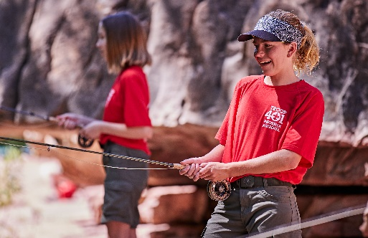
Scout leaders are experts at putting on fun activities for youth but for this event, we should make a few special preparations in addition to a fun family activity.

- First, have an annual calendar sharing the key activities and events for the Troop this upcoming school year.

- Second, know your leadership vacancies and have a leadership chart with blanks showing where every family will have a responsibility within the Troop.

- Third, be prepared to collect membership dues in a way that is effective and easy for your families.

Setup

While some units conduct the Regroup the Troop with a formal meeting, we recommend you take an informal approach by conducting the activity with 3 tables/stops at the entrance, guiding families to visit each as they arrive. Each of the 3 tables or stops have a very specific purpose with a specific leader.

- Welcome, meet the Scoutmaster, receive the Troop calendar, and a Troop Event Promo.
- Meet the Committee Chair, review the leadership sheet vacancies, and sign-up to help.
- Sign-up and Pay Dues, Receive Unit SWAG with the Treasurer or Committee Member.

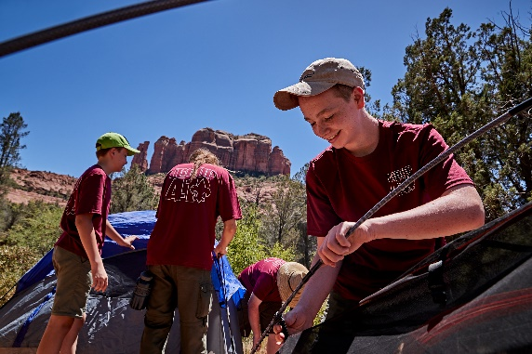
Activity Ideas

Pool Party or Water Game Movie Night
Egg Drop Competition Paper Airplane Competition
Parents vs. Scouts Kickball Picnic at the Park
Olympic Themed Events Ice Cream Social
Dutch Oven Cookout Ultimate Frisbee
Carnival Games Obstacle Course

Key Takeaways and Action Items

Choose a Date and Location for your Regroup the Troop

Share that information with District for Postcards

Assign individuals to personally invite ALL Families

Develop the Troop Calendar with Key Date and Activities

Review Leadership, Identify Vacancies, and Prepare a Leadership Chart

Conduct Regroup the Troop Event, Revitalize Your Troop, and Have Another Great year

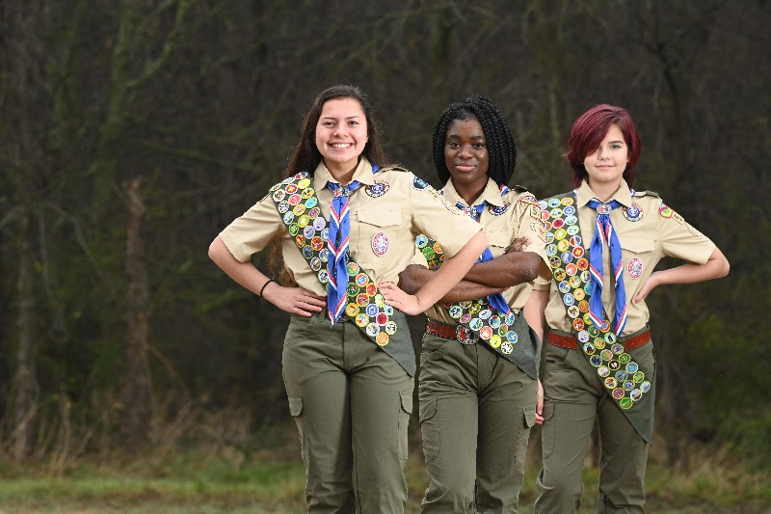

Need Help?
Have Questions?

Contact Your District Leadership

Digital Resources Coming Soon
to the GCC-Hub.org

Cub Pack Position List

Position Title Term Position Description
Charter Org Rep Full Year Key-3 Member - Liaison to the Troop and Charter Partner of the BSA.
Committee Chair Full Year Key-3 Member - Directs the Troop Committee and operations of the Troop.
Cubmaster Full Year Key-3 Member - Oversees program delivery of the Troop.

Assistant Scoutmaster(s) Full Year Assists the Cubmaster, often with a specific set of responsibilities.
Assistant Scoutmaster(s) Full Year Oversee a specific Patrol or set of Patrols and provide mentorship
and coaching to the Patrol Leader

Advancement Chair Full Year Oversees the advancement operations of the Troop.
Advancement Records Full Year Assists with recording all advancements through Scoutbook.
Eagle Coach/Mentor Full Year Provide coaching of Scouts through the Life-to Eagle process.
Troop Treasurer Full Year Oversees the funds and accounting of the Troop.
Fundraising Chair Full Year Oversee all Fundraising Efforts of the Troop.
Popcorn Chair Short-Term Oversee the Fundraising Efforts of the Troop through Popcorn sales.
Camp Cards Chair Short-Term Oversee the Fundraising Efforts of the Troop through Camp Card sales.
Troop Membership Chair Full Year Maintains the Troop roster and ensures proper registration.
New-Member Coordinator Full Year Welcomes and Onboards new members of the Troop
Recruitment Lead Full Year Manages and conducts year-round recruitment efforts.
Spring Recruitment Chair Short-Term Manages the Spring Recruitment (non-scouts) Efforts of the Troop.
Troop Recharter Chair Short-Term Completes the Annual Pack Recharter in Summer.
Crossover Chair Short-Term Manages and conducts the promotion of the Troop to Packs
Troop Trainer Full Year Welcomes and Onboards new leaders within the Troop
Troop Training Admin Full Year Promotes and Tracks the Training Status of Leader’s within the Troop
Summer Camp Promotion Short-Term Promotes participation and shares opportunities for Summer Cub Camp.
Transportation Chair Short-Term Oversees the transportation needs and drivers of the Troop.
Troop Communications Full Year Manages all mass Troop communications, Website, and Social Media.
Troop Admin Full Year Records meeting minutes and tracks committee action items.

Community Service Chair Short-Term Conducts and promotes participation in Community Service events
Holiday Event Chair Short-Term Conducts the annual Holiday event for the Troop held in December.
Den Chief Chair Short-Term Provides leadership to the Den Chief of the Troop.
Scouting for Food Chair Short-Term Conducts the Pack’s Scouting for Food efforts.
Family Camp Chair Short-Term Conducts and promotes participation in a family Camp opportunity.
Winter/Fall Court of Honor Short-Term Conducts the Award Ceremony events for the Troop in Fall/Winter.
Spring Court of Honor Short-Term Conducts the Award Ceremony events for the Troop in Spring.
Regroup the Troop Chair Short-Term Conducts the Regroup the Troop event, held in June/July annually.

NOTE:
Each position can be strongly supported by an assistant to their role and responsibilities. i.e., Assistant Treasurer or even a Co-Treasurer.

Additionally, as needed, examine small roles within the above positions to identify small volunteer opportunities. Examples for these may be someone who helps make advancement purchases or provides treats at an event.

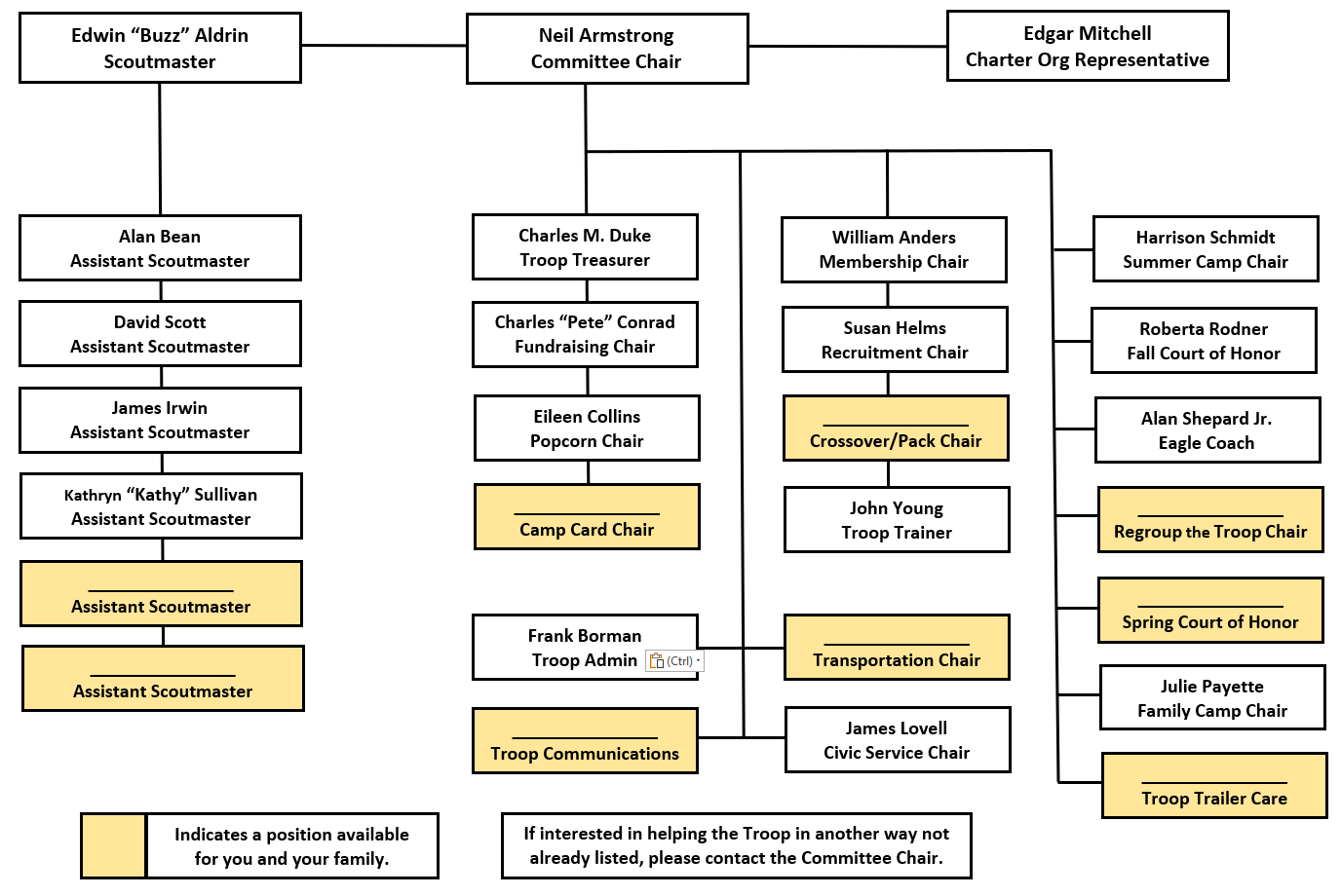
Simple Troop Leadership Chart
Scouting is at it’s best when the entire family is involved. Each family is not just invited but expected to participate in some capacity, large or small. By participating you are not only taking an active role in the development of your Scout(s) but in the development of the entire Troop and community. Thank you for stepping up to join us this year.

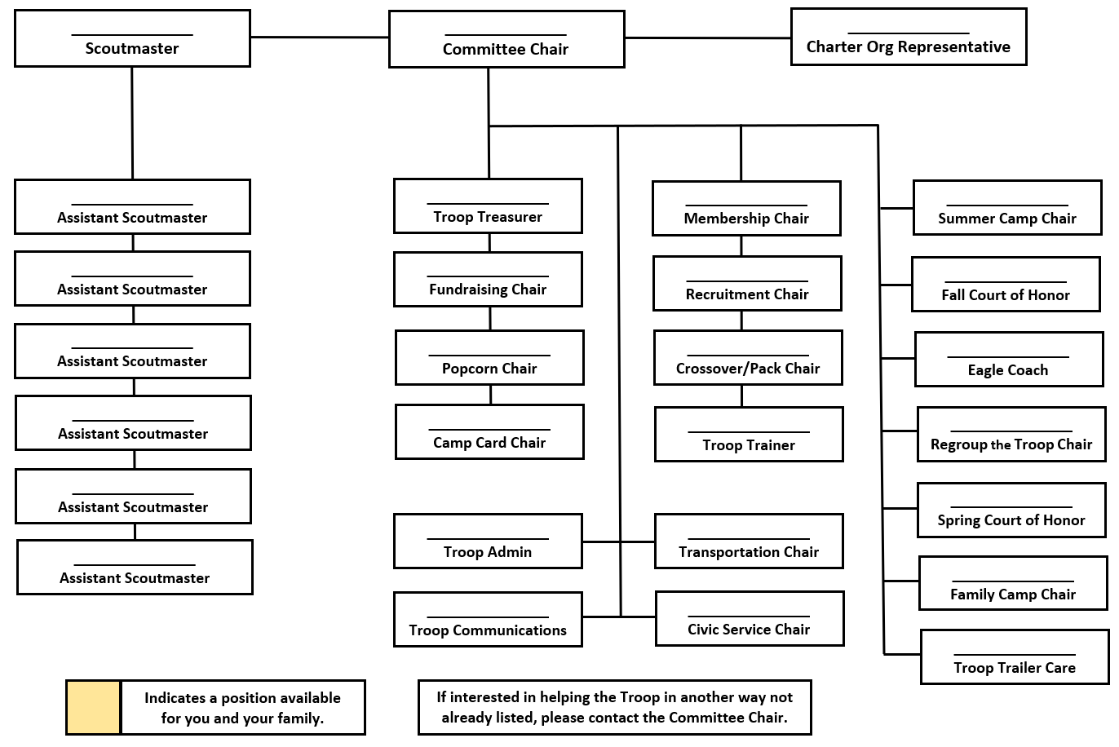

My Troop Leadership Chart
Scouting is at it’s best when the entire family is involved. Each family is not just invited but expected to participate in some capacity, large or small. By participating you are not only taking an active role in the development of your Scout(s) but in the development of the entire Troop and community. Thank you for stepping up to join us this year.

