2022 Unit Camp Card Sales Agreement
Name: _____________________________________________
Unit Type: ________________ Unit Number: ___________
District: _____________________ Phone: _______________
Email: _____________________________________________

Estimated # of Scouts selling: ____________
- My unit agrees to sell Camp Cards in accordance with the money earning policies of the Boy Scouts of America.
- Scout/Parent agrees to properly represent the Boy Scouts while selling Camp Cards and to obtain proper permission from the management or owners of commercial property where Camp Cards may be sold.
- My unit agrees to be fully responsible for the proper accounting of all Camp Cards and monies from the cards sold and understand it is solely responsible for meeting all required deadline dates.
- My unit understands and agrees on all sales turned in by:
May 13th, 2022, for 50% commission.
- After May 13 units will be charged for ALL outstanding cards in their possession.

I recognize that each of these cards has a cash value of $10.00.

By signing below, I agree that we will be charged $5.00 for every unreturned or damaged card by May 13th, 2020.

(Please sign)
Unit Representative: __________________________________

2022 Unit Card Accounting
___________________________________________________
Card Check Out
__________________________________
(Number of cards checked out)
Price per card - - $10.00 each
Value of Camp Cards Issued $___________
___________________________________________________
Card Sales
Money Due to Council:

May 13, 2022

ALL CAMP CARDS MUST BE RETURNED TO COUNCIL OR PAID FOR BY MAY 13, 2022, OR THE UNIT WILL BE CHARGED $5 FOR EVERY UNRETURNED OR DAMAGED CAMP CARD
___________________________________________________
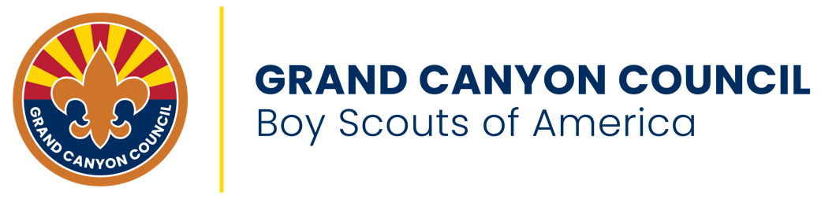

Council Representative: ____________________ Date: ______

RETURN ORIGINAL COPY TO STAFF ADVISOR
EMAIL OR COPY FOR UNIT REPRESENTATIVE

