Grand Canyon Council
2021 Popcorn Leaders’ Guide

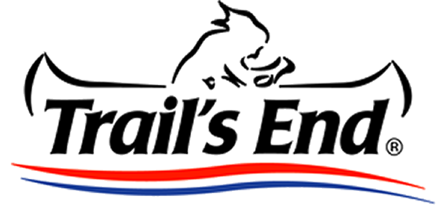

www.grandcanyonbsa.org/popcorn

Edition: July 9, 2021
Welcome to the 2021 Popcorn Fundraiser
For over 35 years the Boy Scouts of America has worked with Trail’s End to empower our Scouts and their leaders to raise the funds they need to go to camp, provide year-round programming, and to empower any Scout to earn their own way through the Scouting program! Fundraising through Popcorn sales is a tested and reliable method to fundraising, and unit leaders have the support, guidance, and training of Council volunteers and staff to guide every unit to success!
For the next several months we will be working to support Scouts and their families across the state as they work hard to earn support for their programs, activities, and experiences that will shape their character and wellbeing for years to come! The Popcorn Fundraiser may feel hectic or overwhelming at times, but with prior planning and organization, it can be a very smooth and dependable process which will support your unit, its Scouts, and enable families of all backgrounds the ability to enjoy a quality program.
While this last year has brought its own challenges and surprises, we look forward to the 2021 Popcorn Fundraiser and are here to guide you every step of the way. Please do not hesitate to reach out to Council staff or your District Kernel for support along the way, although many of the answers you may need can be sourced from www.grandcanyonbsa.org/popcorn, or the Trails End Kernel’s Guide.
Wil and Sondra Wendt Nick Hutchinson
Council Kernels Council Staff Advisor

For many questions concerning the Trails End system, budgeting, planning, and ordering, please refer to the comprehensive Trails End Kernel’s Guide. This guide will inform you of the Grand Canyon Council contacts, important dates, and additional considerations.

Table of Contents
3 Important Dates
3 Council/District Contacts
4 New for 2021
5 2021 Product lineup
6 Unit Kernel Role Description
7 Unit Orders and Returns
7 Distribution sites
8 Resources

Important Dates
Date |  | Event
June 29 | Council Virtual Kickoff (for those who want to participate in storefronts)
July 19-21 | Storefront Selections begin (varies by unit, click this link for details)
Aug. 1 | Council Virtual Kickoff
Aug. 31^ | Show and Sell Orders Submission Deadline
Sept. 16-17# | Show and Sell Delivery and Product pickup
Sept. 27^ | Midsale Order #1 Submission Deadline
Oct. 13-15# | Midsale Order Distribution
Nov. 5^ | Take Order Submission Deadline
Nov. 18-19# | Take Order Orders delivered and distributed.
Dec. 10 | Fundraiser is closed. Deadline to settle all balances and submit prize orders.
- Units are encouraged to establish internal deadlines with their units to collect commitments, orders, and monies so that the kernel has enough time to aggregate orders, inventory product, determine needs, assist stragglers, and assess strategic adjustments to the unit fundraiser.
- ^ = No late order submissions will be accepted. We cannot delay the entire Council order or adjust our distribution dates to accommodate units who do not meet published deadlines. It is the unit’s responsibility to ensure that their orders are complete and timely.
- # - Popcorn MUST be picked up by 4pm Friday from our distribution sites as we cannot hold product on site.

Council and District Contacts…. and when to contact them!
Council Kernels - General popcorn questions, unit strategies and motivation, fundraiser troubleshooting
Sondra Wendt SKWendt@cox.net
Council Advisor - General popcorn questions, unit orders, troubleshooting
Nick Hutchinson Nick.Hutchinson@scouting.org 602-955-7747,204
Trails End App Support – everything related to the Trails End app.
Trails End teappsupport@trails-end.com
District Kernels – General popcorn questions, unit orders, troubleshooting
Central Sabrina Mauch brina.mauch@gmail.com
Gila River Misti Nichols mistinichols.scouting@gmail.com
Lost Dutchman Terri Farrington terri@gilbertcubs.org
Pinnacle Peak Heather Babcock Heathbabcock1@gmail.com
Ponderosa Amy Fredrick fredrick2798@gmail.com
Sonoran Sunset Paul Stithem T3COR@cox.net

New for 2020 Fundraising Year
Storefronts
Units are encouraged to solicit storefronts within their immediate community and to support their Scouts’ sales efforts. We highly recommend Scouts’ houses of worship, school sports games, tailgates for professional sports, and anywhere with heavy foot traffic. As we have already worked with many corporate entities to arrange Council-wide opportunities, please do not reach out to Fry’s Food Stores or any other locations already made available as they have already provided opportunities.
Beginning 2021, Trails End will be supporting Grand Canyon Council in securing storefronts with national chains. We expect over 9,000 hours worth of storefronts at locations such as Michaels, Ace Hardware, Tractor Supply, Olsen’s Grain, Flying J’s, Lowes, Loves, a few Walmarts, Bass Pro, Sportsman’s Warehouse, and much more! These 9,000 hours are in addition to the ~3,500 hours Council is given by Fry’s Food Stores each year, so there will be no shortage of storefronts available in 2021! All storefronts will be made in the Trails End Leaders Portal, and will automatically populate within your unit’s storefront calendar so that your Scouts may sign up for shifts within your unit. This process cannot be completed outside of the Trails End system, so we recommend you ensure that your families have downloaded the app or have an account online.
Trail’s End will distribute the storefront shifts to units through the Trail’s End Leader Portal beginning in July. This is a national rollout and is not customizable for Grand Canyon Council. The distribution schedule for all storefronts is as follows:
- Monday, July 19 – Top Selling Units, 1 Picks within their district
- Tuesday, July 20 – Top Selling Units, 2 Picks within their district
- Wednesday, July 21 – All units, 1 Picks within their districts
- Thursday, July 22 – All units, 2 Picks within their district
- Friday, July 23 – All units, 4 Picks within their district
- Saturday, July 24 – All units, unlimited picks within their council

Product changes:
- Cheese Lovers is replaces with Sweet & Savory Collection, which includes White Cheddar and Salted Caramel
- Popping Corn Microwavable is back with a 12 pack of popping corn!
- All products are now available online.
- Sweet & Salty Kettle Corn is new.
- Chocolatey Caramel Crunch & Chocolate Lovers are replaced with Chocolate Preztels.
  - Chocolate products will still not ship to Arizona until it is safe to ship without risking melting, traditionally mid-November.
- The Military Donation is now the American Heroes Donation to include US military, first responders and healthcare workers.

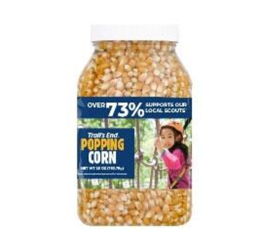
2021 Product Lineup:
Product Cost per Notes:
Sweet & Savory Collection: $40 contains Salted Caramel & White Cheddar
Chocolatey Pretzels $25 Not available until Take-order
Salted Caramel Popcorn: $25 20oz Bag
Blazin’ Hot Popcorn: $20 8oz bag
White Cheddar Popcorn: $20 9oz bag
Unbelievable Butter Microwave $20 Microwave – 12 bags
Sweet and Salty Kettle Corn $20
Unbelievable Butter Popcorn: $15 7oz bag “Big bag”, not popping
Popping Corn jar: $15 28oz jar
Caramel Corn Popcorn: $10 9oz bag
American Heroes Donation $50 or $30 *
- * = All donations sold in the TE app will be invoiced to units and councils to eliminate confusion about this item needing to be delivered, ordered to unit or council.
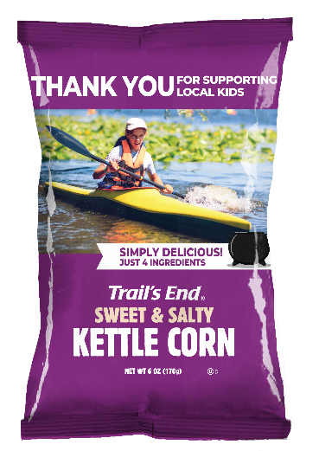

Unit Popcorn Kernel Responsibilities
- Be the “Go to” person for your unit!
- Coordinate and promote the popcorn sale in your unit.
- Attend the Council Kickoff.
- Facilitate a unit kickoff mid-August.
- Coordinate storefront opportunities to help Scouts sale as is possible. You may use our template letter as reference.
- Contact all the Scouts/parents in your unit and confirm their participation in the sale, as well as sales goal.
- Assist scouts and leaders in setting personal goals as well as a cumulative unit goal based off Scout participation.
- Have all Scouts create an account to sell online or through the app at http://sell/trails-end.com
- Add the total needs for each order and submit them before the deadline for each order.
- Coordinate your popcorn pick up on the distribution dates. Arrange for volunteers to help you load and transfer popcorn as necessary.
- Distribute popcorn within your unit and ensure that orders are delivered as soon as possible.
- Track inventory to determine if more popcorn should be ordered, or if there are opportunities to transfer excess popcorn to other units.
- Collect money for orders and submit money owned to Council.
- Order and distribute patches, prizes, and other incentives earned by participating Scouts.
- Contact your District or Council Kernel with any questions.

Unit Orders and Returns
Unit orders are due by the posted dates on the timeline. No late orders will be accepted.
- It takes up to 8 hours’ time to aggregate 100+ unit orders, including determining the number of pallets and layers necessary per truck per delivery location. One late order could mean having to start over from scratch, pay extra for rush shipping for hundreds of thousands worth of product, or delaying the entire Council order. Beginning 2020, there will be no orders accepted past the order deadline.
- Popcorn inventory is being created upon ordering, providing the freshest product to our units. Orders will take two weeks to deliver once Council has submitted the aggregate Council order. Late orders could mean we may lose our distribution sites.
- Due to the addition of two midsale orders and a new Council office location on a second floor with less storage space, additional popcorn will not be available to replenish inventories or to fill late orders.
- Grand Canyon Council does not accept returns of unsold popcorn from units. Units should only order product that they intend to sell and should order in line with their Scout goals and participation.
- Units may mitigate their risk, or even have a no-risk sale, by focusing on or only engaging in Take Orders and Online Sales.
- Every unit should order an amount of popcorn based on the goals and participation of Scouts within their unit. Please do not submit an order without first determining the level of Scout participation.
  - The final Take Order order will allow units to order the exact number of containers they need to fulfill needs, and units should use any excess popcorn they may have to fill those orders before submitting an order for addition product.
- Grand Canyon Council will provide you with a popcorn order calculator that will allow you to determine a variety of product in line with your goal, based off of ratios of popcorn sold in prior years.
- Grand Canyon Council will encourage units to trade and transfer product throughout the sale to find more popcorn or take product from of other units who ordered too much. This can be completed via the Trails End website! Units with excess popcorn should make it available to other units as early as possible.
- Grand Canyon Council will provide an annual budget planner to help units gauge a goal amount per Scout based off of program participation.
- Units keep their commission immediately but must pay Council the remaining balance by the deadlines posted on the timeline scheduled above.

Distribution Sites
Popcorn is delivered on Wednesdays, with distribution Thursday and Friday. Show and Sell popcorn MUST be picked up by 5pm Friday.
Show and Sell – Sept. 16-17
- Lost Dutchman, Gila River
  - United Food Bank of Mesa – 245 S Nina Dr. Mesa, AZ
- Sonoran Sunset, Pinnacle Peak, and Central
  - Shamrock Farms – 2901 E Virginia Ave, Phoenix, AZ
- Ponderosa District
  - Flagstaff Family Food Bank – 3805 E Huntington Dr. Flagstaff, AZ
Midsale Orders and Take Order - Oct. 13-15, Nov. 18-19
- All Districts
  - Heard Scout Pueblo - 1901 e Dobbins Rd. Phoenix, AZ

RESOURCES
- Grand Canyon Council Popcorn webpage
- Grand Canyon Council Fundraising Forum – Our Council Facebook group for unit fundraising chairs.
- Advancements earned through Popcorn
- Annual Budget Planner
- Instructions on how to order door hangers or business cards on Vistaprint
  - Business Cards
  - Door Hangers
- Unit Kickoff – Powerpoint Template
- Unit Kickoff – Checklist
- Scout Sales – Planning Worksheet for Goal Setting
- Scout Sales – Script Cards
- Storefront Code of Conduct
- Top Sellers Pledge
- Trails End Resources

