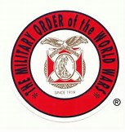
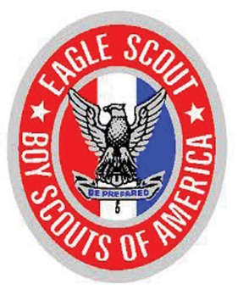
Eagle Scout Recognition

The Military Order of World Wars (MOWW) congratulates you on your achievement of Eagle Rank. Founded in 1919 by General John J. Pershing to promote the welfare of our Nation. MOWW has long supported the Boy Scouts of America.

Military Order of World Wars Chapters recognize Scouting excellence by presenting MOWW’s Eagle Scout Certificate of Recognition, an embossed certificate and presentation folder.

MOWW is a non-profit veterans organization chartered by Congress and recognized by the Department of Veterans Affairs. Officers and their families are members of MOWW in order to unite in a strong effort to promote national security, patriotism, good citizenship, and service to country.

“It is nobler to serve than to be served”.

_ _ _ _ _ _ _ _ _ _ _ _ _ _ _ _ _ _ _ _ _ _ _ _ _ _ _ _ _ _ _ _ _ _ _ _ _ _ _ _ _ _ _ _ _ _ _ _ _ _ _

Mail or email completed form to : Charles Mackey
4217 E. Muirwood Drive, Phoenix, AZ
Phone: 480-706-0120
Email: dluther33@cox.net

Scout’s name: _____________________________ Contact phone/email: __________________

Parent’s name: _______________________________

Scoutmaster: _________________________________ Troop No. : _______

___ Yes, I would like my certificate presented by a member of MOWW
My Eagle Ceremony is : date: _____________ Location: ___________________________

___ Please mail my certificate to : ________________________________________
________________________________________
________________________________________

