2021 Unit Camp Card Sales Agreement
Name: ___________________________________________________
Unit Type: __________________ Unit Number: _________________
District: ________________________ Phone: ___________________
Email: ___________________________________________________
Estimated # of Scouts selling: ____________
- My unit agrees to sell Camp Cards in accordance with the money earning policies of the Boy Scouts of America.
- Scout/Parent agrees to properly represent the Boy Scouts while selling Camp Cards and to obtain proper permission from the management or owners of commercial property where Camp Cards may be sold.
- My unit agrees to be fully responsible for the proper accounting of all Camp Cards and monies from the cards sold and understand it is solely responsible for meeting all required deadline dates.
- My unit understands and agrees on all sales turned in by:
May 6th, 2020 for 50% commission.
- After May 14 units will be charged for ALL outstanding cards in their possession.

I recognize that each of these cards has a cash value of $10.00.

By signing below, I agree that we will be charged $10.00 for every unreturned or damaged card by May 6th, 2020.

(Please sign)
Unit Representative: _______________________________________

2021 Unit Card Accounting
___________________________________
Card Check Out
__________________________________
(number of cards checked out)
Price per card - - $10.00 each
Value of Camp Cards Issued $_________________
__________________________________________
Card Sales
Money Due to Council:

May 6, 2021 to receive 50% commission

ALL CAMP CARDS MUST BE RETURNED TO COUNCIL OR PAID FOR BY MAY 14, 2020
or the unit will be charged $10 for every unreturned or damaged card.
_________________________________________________________
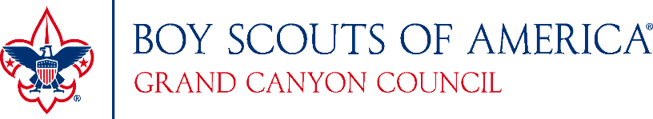

Council Representative: _____________________________Date: ________

RETURN ORIGINAL COPY TO CAMP CARD STAFF ADVISOR
EMAIL OR COPY FOR UNIT REPRESENTATIVE

