2021 Scout/Parent Camp Card Sale Agreement
_________________________________________________
Scout’s Name: ____________________________________________
Parent Name: _____________________________________________
Email: ___________________________ Phone: _________________
Unit Information: __________________________________________
- Scout/Parent agrees to sell Camp Cards in accordance with money earning policies of the Boy Scouts of America.
- Scout/Parent agrees to properly represent the Boy Scouts of America while selling Camp Cards and to obtain proper permission from the management or owners of commercial property where Camp Cards may be sold.
- Scout/Parent agrees to be fully responsible for the proper accounting of all Camp Cards and monies from the cards sold and understand they are solely responsible for meeting all required deadline dates.
- Scout/Parent understands that the UNIT deadline to return cards to COUNCIL is May 6, 2021 for 50% commission.
- All monies and unsold cards are to be returned to the unit camp card chair on or before:_________________________

I recognize that each of these cards has a cash value of $10.00. By signing below, I agree that we will be charged $10.00 on May 14, 2020 for every card that is unreturned to Council or damaged.

(Please sign)
Scout: ___________________________________________________

2021 Scout/Parent Card Accounting Sheet
_________________________________________________

Card Check Out

_______________________________
(number of cards checked out)

Price per card --- $10.00
Value of Camp Cards Issued $_________________
_________________________________________________

Card Return

_________________________________
(number of undamaged cards returned)

Money Received

$ ___________________________

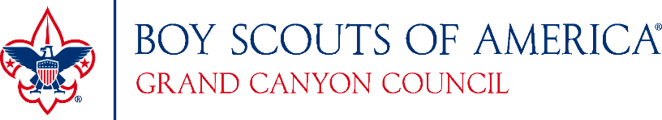

Parent: ___________________________________ Date: __________

