Grand Canyon Council
2020 Popcorn Leaders’ Guide

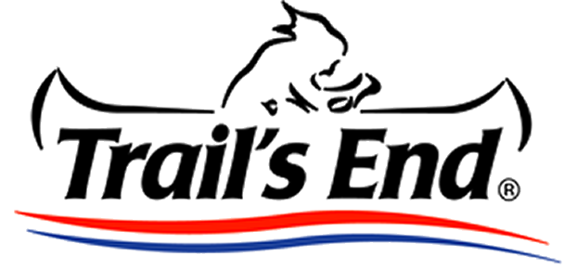

www.grandcanyonbsa.org/popcorn

Edition: July 29, 2020
Welcome to the 2020 Popcorn Fundraiser
For over 35 years the Boy Scouts of America has worked with Trail’s End to empower our Scouts and their leaders to raise the funds they need to go to camp, provide year round programming, and to empower any Scout to earn their own way through the Scouting program! Fundraising through Popcorn sales is a tested and reliable method to fundraising, and unit leaders have the support, guidance, and training of Council volunteers and staff to guide every unit to success!
For the next several months we will be working to support Scouts and their families across the state as they work hard to earn support for their programs, activities, and experiences that will shape their character and wellbeing for years to come! The Popcorn Fundraiser may feel hectic or overwhelming at times, but with prior planning and organization, it can be a very smooth and dependable process which will support your unit, its Scouts, and enable families of all backgrounds the ability to enjoy a quality program.
While this year has brought its own challenges and surprises, we look forward to the 2020 Popcorn Fundraiser and are here to guide you every step of the way. Please do not hesitate to reach out to Council staff or your District Kernel for support along the way, although many of the answers you may need can be sourced from www.grandcanyonbsa.org/popcorn, or the Trails End Kernel’s Guide.
Wil and Sondra Wendt Matthew Graham
Council Kernels Council Staff Advisor

For many questions concerning the Trails End system, budgeting, planning, and ordering, please refer to the comprehensive Trails End Kernel’s Guide. This guide will inform you of the Grand Canyon Council contacts, important dates, and additional considerations.

Table of Contents
3 Important Dates
3 Council/District Contacts
4 New for 2020
5 2020 Product lineup
6 Considerations for Covid-19
7 Unit Kernel Role Description
8 Unit Orders and Returns
8 Distribution sites
9 Resources

Important Dates
July 1, 2020 | Scouts may begin online sales and earn a 5% bonus on Amazon gift card prizes for sales until 8/15.
Aug. 2, 2020 | Council Kickoff at Orangewood Church, 2:30-4:30pm. Zoom/remote participation available.
Aug. 17, 2020 | Storefront signups open at 10:00am.
Aug. 31, 2020 | Show and Sell Orders Submission Deadline^
Sept. 17-18, 2020 | Show and Sell Delivery and Product pickup#
Sept. 18-20, 2020 | Fry's Storefront Weekend #1*
Sept. 21, 2020 | Midsale Order #1 Submission Deadline^
Oct. 5, 2020 | Midsale Order #2 Submission Deadline^
Oct. 8-9, 2020 | Midsale Order #1 Distribution
Oct. 16-18, 2020 | Fry's Storefront Weekend #2*
Oct. 22-23 | Midsale Order #2 Distribution
Nov. 2, 2020 | Take Order Submission Deadline^
Nov. 19-20, 2020 | Take Order Orders delivered and distributed.
Dec. 7, 2020 | Fundraiser is closed. Deadline to settle all balances and submit prize orders.
- Units are encouraged to establish internal deadlines with their units to collect commitments, orders, and monies so that the kernel has enough time to aggregate orders, inventory product, determine needs, assist stragglers, and assess strategic adjustments to the unit fundraiser.
- * = Additional storefront sales may be scheduled and will be added to the calendar at www.grandcanyonbsa.org/popcorn as they become available.
- ^ = No late order submissions will be accepted. We cannot delay the entire Council order or adjust our distribution dates to accommodate units who do not meet published deadlines. It is the unit’s responsibility to ensure that their orders are complete and timely.
- # - Popcorn MUST be picked up by 4pm Friday from our distribution sites as we cannot hold product on site.
Council and District Contacts…. and when to contact them!
Council Kernels - General popcorn questions, unit strategies and motivation, fundraiser troubleshooting
Sondra Wendt SKWendt@cox.net
Wil Wendt WilWendt@hotmail.com
Council Advisor - General popcorn questions, unit orders, troubleshooting
Matthew Graham Matthew.Graham@scouting.org 602-955-7747,229
Storefront Registrar - Storefront registration, site cancelations
Donna Kutarnia Donna.Kutarnia@scouting.org 602-955-7747,239
Trails End App Support – everything related to the Trails End app.
Trails End teappsupport@trails-end.com
District Kernels – General popcorn questions, unit orders, troubleshooting
Central Carol Baxter cbax66@yahoo.com
Gila River Misti Nichols mistinichols.scouting@gmail.com
Lost Dutchman Terri Farrington terri@gilbertcubs.org
Pinnacle Peak Heather Babcock Heathbabcock1@gmail.com
Ponderosa Amy Fredrick fredrick2798@gmail.com
Sonoran Sunset Paul Stithem T3COR@cox.net
New for 2020 Fundraising Year
Selling:
For many families, in-person fundraising may be a challenge this year, so we are making changes to allow for contactless fundraising.
- The Online Direct store will now include the traditional products sold at the traditional prices including the Caramel Corn. Customers will pay the cost of shipping.
- Scouts can record an Online Direct sale in the Trail’s End App while selling door to door or over the phone.
  - For added safety, Scouts can start a sale and send a text message link to the customer so that they can fill in their credit card and shipping information.
- Online Direct orders will be popped fresh to order, ensuring the popcorn is minimally handled and delivered directly to the customers door.

Prizes:
Online Direct is the safest method of sales for your Scouts and volunteers and minimizes the financial risk to your unit and council. To encourage Scouts to adopt this new way to sell, Trail’s End is improving Trail’s End Rewards*. View the prize levels
- Each Rewards level is now based on points, rather than dollars.
  - Scouts earn DOUBLE POINTS for every dollar in Online Direct sales
  - Scouts earn 1.5 points for every dollar in credit sales
  - Scouts earn one point for every dollar in cash sales.
- Scouts will earn bigger prizes faster than ever before when they sell with Online Direct and credit cards.

Scholarship:
- Entry into the Trails End Scholarship has been discontinued after the 2019 fundraiser.
- Scouts who have entered the scholarship in 2019 or previously are grandfathered in.
- Trail’s End has opted to discontinue the program due to low matriculation (<20% participation) and spread the value
across rewards for all Scouts.

Product changes:
- Jalapeno Cheddar and Caramel Corn with Nuts have been replaced with Blazin’ Hot.
- Cheese Lovers Collection now includes two large bags, one each of White Cheddar & Blazin’ Hot.
- Popping Corn now comes in a 28-oz jar instead of popping bags.
- All products are now available online.
  - Chocolate products will still not ship to Arizona until it is safe to ship without risking melting.
- Due to limited supply, Unbelievable Butter microwave will be available Online Direct only.
- We are introducing a ready-to-eat “BIG BAG” of Unbelievable Butter
- The Kettle Corn Big Bag has been delayed to 2021.
- Chocolatey Caramel Crunch & Chocolate Lovers will be available Online Direct only.
- The Military Donation is now the American Heroes Donation to include US military, first responders and healthcare
workers.

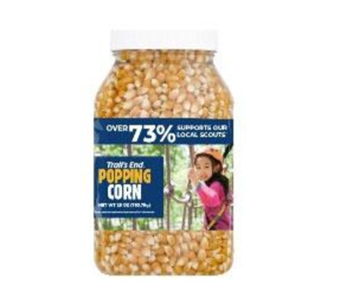
2020 Product Lineup:
Product Cost per Notes:
Cheese Lovers Collection: $35 contains Blazin’ Hot & White Cheddar
Salted Caramel Popcorn: $25 20oz Bag
Blazin’ Hot Popcorn: $20 8oz bag
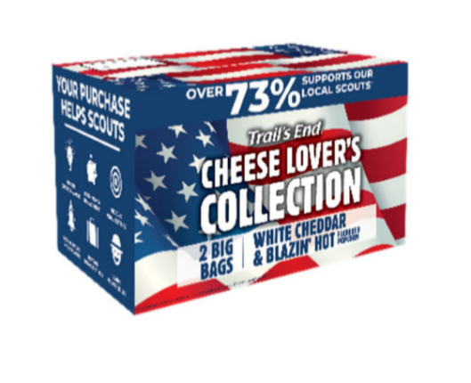
White Cheddar Popcorn: $20 9oz bag
Unbelievable Butter Popcorn: $15 7oz bag “Big bag”, not popping
Popping Corn jar: $15 28oz jar
Caramel Corn Popcorn: $10 9oz bag
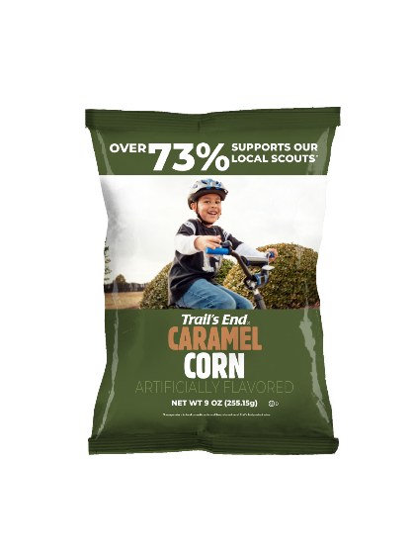
American Heroes Donation $50 or $30 *
- * = All donations sold in the TE app will be invoiced to units and councils to eliminate confusion about this item needing to be delivered, ordered to unit or council.
Online Only
Chocolate Caramel Crunch $30 ^
Chocolate Lovers $70 ^
- Includes two bags dark choc. salted caramels, one bag choc. Caramel crunch
Unbelievable Butter (Popping) $25
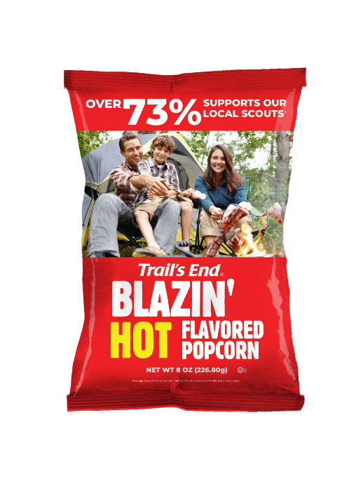
- ^ = Chocolate products will not ship until after October, and only after a week of weather with the highs under 90*F in order to prevent melting.
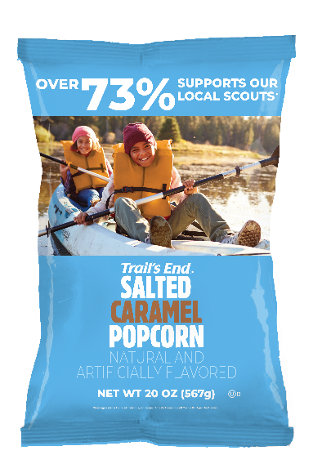
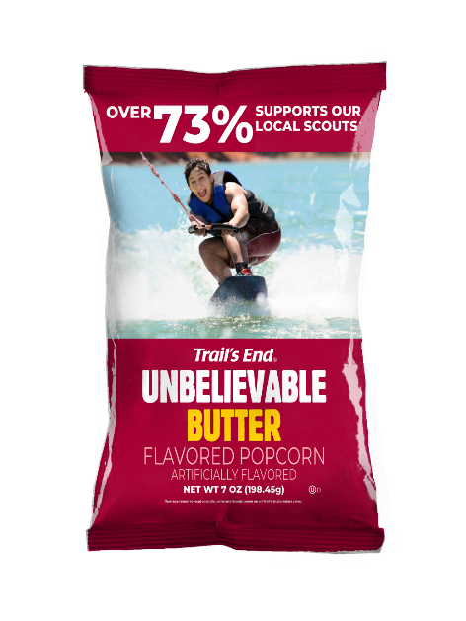

Considerations for Covid-19
2020 presents a variety of novel challenges to the annual popcorn sale, including how to engage in face to face sales in a world of social distancing, how to order an appropriate amount of product in an unpredictable year, and how to protect Scouts from potential spread of sickness.
Health and Safety
- Storefronts – some businesses, houses of worship, or schools may be unwilling to allow units to set up booths or approach customers. Be flexible with your sales strategies, look for additional opportunities to interact with customers remotely, and encourage Scouts to allow customers to approach them at storefronts.
- Social Distancing and health measures – Scouts who are selling in person should be sure to respect the safety precautions and needs of others by keeping an appropriate distance, allowing customers to approach tables at sites, and wearing face masks. Regardless of your Scouts’ personal health or their beliefs, if they are hoping to interact with many people throughout the day they should engage in practices that reduce potential spread of sickness.
- Units should encourage each Scout to carry hand sanitizer to use as necessary.
Inventory and Sales Strategies
- Mitigate risk by focusing sales - Units may reduce risk, or even arrange a completely risk-free sale, by focusing unit participation on Online and/or Take Order sales. With both sales types, there is no need to pre-order popcorn, and thus no possible risk of having excess inventory. Concerning Take Order orders, units will receive exactly as many containers or individual bags of popcorn that they require to meet their sales. Online orders will be shipped directly to the consumer with each transaction.
- Smaller orders - Due to the unpredictability of the impact of Covid-19 on sales, Units are encouraged to make a smaller Show and Sell order (due Aug. 31, distributed Sept. 17-18) compared to recent years. Their order should be no more than 50% of their Show and Sell order from 2019. Units should plan on putting their best effort throughout the first two weekends, which are also the best for sales, assess their inventory and needs, then order additional popcorn for the remainder of the fundraiser through the midsale orders due Sept. 29 and Oct. 5th.
- Units should aim to sell the entirety of show and sell and midsale popcorn through wagon sales or storefronts and can use remaining inventory to fill Take Order needs.
- Always keep in mind that additional popcorn may be ordered through the Midsale or Take Order, but excess popcorn may not be returned to Council.

Unit Popcorn Kernel Responsibilities
- Be the “Go to” person for your unit!
- Coordinate and promote the popcorn sale in your unit.
- Attend the Council Kickoff.
- Facilitate a unit kickoff mid-August.
- Coordinate storefront opportunities to help Scouts sale as is possible. You may use our template letter as reference.
- Contact all the Scouts/parents in your unit and confirm their participation in the sale, as well as sales goal.
- Assist scouts and leaders in setting personal goals as well as a cumulative unit goal based off Scout participation.
- Have all Scouts create an account to sell online or through the app at http://sell/trails-end.com
- Add the total needs for each order and submit them before the deadline for each order.
- Coordinate your popcorn pick up on the distribution dates. Arrange for volunteers to help you load and transfer popcorn as necessary.
- Distribute popcorn within your unit and ensure that orders are delivered as soon as possible.
- Track inventory to determine if more popcorn should be ordered, or if there are opportunities to transfer excess popcorn to other units.
- Collect money for orders and submit money owned to Council.
- Order and distribute patches, prizes, and other incentives earned by participating Scouts.
- Contact your District or Council Kernel with any questions.

Unit Orders and Returns
Unit orders are due by the posted dates on the timeline. No late orders will be accepted.
- It takes up to 8 hours’ time to aggregate 100+ unit orders, including determining the number of pallets and layers necessary per truck per delivery location. One late order could mean having to start over from scratch, pay extra for rush shipping for hundreds of thousands worth of product, or delaying the entire Council order. Beginning 2020, there will be no orders accepted past the order deadline.
- Popcorn inventory is being created upon ordering, providing the freshest product to our units. Orders will take two weeks to deliver once Council has submitted the aggregate Council order. Late orders could mean we may lose our distribution sites.
- Due to the addition of two midsale orders and a new Council office location on a second floor with less storage space, additional popcorn will not be available to replenish inventories or to fill late orders.
- Grand Canyon Council does not accept returns of unsold popcorn from units. Units should only order product that they intend to sell and should order in line with their Scout goals and participation.
- Units may mitigate their risk, or even have a no-risk sale, by focusing on or only engaging in Take Orders and Online Sales.
- Every unit should order an amount of popcorn based on the goals and participation of Scouts within their unit. Please do not submit an order without first determining the level of Scout participation.
  - In 2020, Council is encouraging units to order no more than 50% of their 2019 sales with their Show and Sale order.
  - TWO midsale orders will be available for units to top off their inventory.
  - The final Take Order order will allow units to order the exact number of containers they need to fulfill needs, and units should use any excess popcorn they may have to fill those orders before submitting an order for addition product.
- Grand Canyon Council will provide you with a popcorn order calculator that will allow you to determine a variety of product in line with your goal, based off of ratios of popcorn sold in prior years.
- Grand Canyon Council will encourage units to trade and transfer product throughout the sale to find more popcorn or take product from of other units who ordered too much. This can be completed via the Trails End website! Units with excess popcorn should make it available to other units as early as possible.
- Grand Canyon Council will provide an annual budget planner to help units gauge a goal amount per Scout based off of program participation.
- Units keep their commission immediately but must pay Council the remaining balance by the deadlines posted on the timeline scheduled above.

Distribution Sites
Popcorn is delivered on Wednesdays, with distribution Thursday and Friday. Show and Sell popcorn MUST be picked up by 5pm Friday.
Show and Sell – Sept. 17-18
- Lost Dutchman, Gila River
  - United Food Bank of Mesa – new location – 358 E Javelina Ave. Mesa, AZ
- Sonoran Sunset, Pinnacle Peak, and Central
  - Shamrock Farms – 2901 E Virginia Ave, Phoenix, AZ
- Ponderosa District
  - Flagstaff Family Food Bank – 3805 E Huntington Dr. Flagstaff, AZ
Midsale Orders and Take Order – MS1: Oct 8-9, MS2: 22-23, TO: Nov 19-20.
- All Districts
  - Heard Scout Pueblo - 1901 e Dobbins Rd. Phoenix, AZ
RESOURCES
- Grand Canyon Council Popcorn webpage
- Grand Canyon Council Fundraising Forum – Our Council Facebook group for unit fundraising chairs.
- 2020 Kernel Guide to Trails End Popcorn
- Advancements earned through Popcorn
- Annual Budget Planner
- Instructions on how to order door hangers or business cards on Vistaprint
  - Business Cards
  - Door Hangers
- Unit Kickoff – Powerpoint Template
- Unit Kickoff – Checklist
- Scout Sales – Planning Worksheet for Goal Setting
- Scout Sales – Script Cards
- Storefront Code of Conduct
- Take Order Form/Prize Sheet
- Top Sellers Pledge
- Trails End Resources

