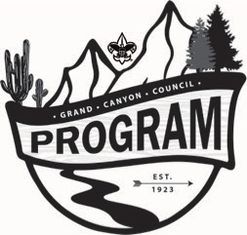
Civic Service
Committee

Purpose: To organize opportunities for all scouts and scouters in the Grand Canyon Council to participate in civic service engagements which allow our members to benefit the community, improve community relationships, and allow our Scouts to be friendly, helpful, and courteous to our communities at large.

Key Functions

Program
- Scouting for Food
- Scout Expo
- Veterans Day/Memorial Day flower placement at cemeteries
- Council Wide Days of Service
- Community/Park clean up days
- Unique events/outreach
- Coordinate with other councils to promote programs and resources
- Coordination with other agencies, such as the YMCA, School Districts, city Parks and Rec. Departments, etc. for joint programs or use of facilities.
Development
- Train and educate leaders on how to record service hours and participation
- Encourage units to keep records current so that Council can confirm and report metrics of service projects in the community.
- Advise and provide guidance on new partnerships and opportunities for civic service that would be of interest to scouts.
- Identify new opportunities for Grand Canyon Council to partner with organizations to synergize on projects pertaining to mutual missions and goals.
- Create Council-wide days of service which enable the Boy Scouts to have a visible impact on the community, as well as projects that promote and project our presence in the community.
- Recognize units with the most recorded service hours annually, total and per scout.
- Recognize unique and outstanding projects and the scouts and leaders who organized the projects.
- Establish a succession plan for process identifying the next Civic Service leaders for key roles.

Committee Chair-
Vice Chair-
Committee Specific Appointments:
- Scouting for Food
- Memorial Day Flowers at Veterans Cemetery

